

Contents

**Key Components of a Database** 2

**Types of Databases** 2

**Functions of a Database** 3

**Examples of Database Usage** 3

**Document Database** 4

**MongoDB: A Popular Document Database** 4

Advantages of Using Documents 4

Key Features of MongoDB 4

How to Install MongoDB on Windows 5

Key Concepts in MongoDB: Query, Collection, and Document 7

MongoDB CRUD Operations 9

Key Concepts 11

Example 11

Distributed Queries in MongoDB 12

MongoDB Write Operations 13

Indexes in MongoDB 15

Working with Arrays in MongoDB 17

Creating and Managing Capped Collections in MongoDB 19

Using MongoDB's mongoimport and mongoexport Tools 20

Conclusion 22

**Databases**

A database is a structured collection of data that is stored and accessed electronically. It allows for efficient storage, retrieval, and management of data. Databases are designed to handle large amounts of information and provide mechanisms to ensure data integrity, security, and performance. They are used in a wide range of applications, from small personal projects to large enterprise systems.

**Key Components of a Database**

1. **Data**:
   * The actual information stored in the database, such as text, numbers, images, and more.
2. **Database Management System (DBMS)**:
   * Software that interacts with the database to manage data. It provides an interface for users and applications to interact with the database, ensuring data is stored, retrieved, and manipulated efficiently and securely.
3. **Schema**:
   * The structure of the database, defining how data is organized. This includes the tables, fields, and relationships between tables in relational databases, or the collections and documents in document databases.
4. **Tables/Collections**:
   * In relational databases, data is organized into tables, which consist of rows and columns.
   * In document databases, data is stored in collections, which contain documents.
5. **Queries**:
   * Requests for data or operations on data. Queries are typically written in a specific language, such as SQL for relational databases or a query language specific to a particular NoSQL database.
6. **Indexes**:
   * Structures that improve the speed of data retrieval operations on a database at the cost of additional storage space and slower write operations.

**Types of Databases**

1. **Relational Databases**:
   * Store data in tables with rows and columns.
   * Use SQL (Structured Query Language) for querying and managing data.
   * Examples: MySQL, PostgreSQL, Oracle Database.
2. **NoSQL Databases**:
   * Designed for specific data models and have flexible schemas.
   * Types include document databases (e.g., MongoDB), key-value stores (e.g., Redis), column-family stores (e.g., Cassandra), and graph databases (e.g., Neo4j).
3. **In-Memory Databases**:
   * Store data primarily in memory for fast access.
   * Examples: Redis, Memcached.
4. **NewSQL Databases**:
   * Aim to provide the scalability of NoSQL databases while maintaining the ACID properties of traditional relational databases.
   * Examples: Google Spanner, CockroachDB.
5. **Time-Series Databases**:
   * Optimized for time-stamped or time-series data.
   * Examples: InfluxDB, TimescaleDB.
6. **Object-Oriented Databases**:
   * Store data as objects, similar to object-oriented programming.
   * Examples: Db4o, ObjectDB.

**Functions of a Database**

1. **Data Storage**:
   * Efficiently store large volumes of data.
2. **Data Retrieval**:
   * Quickly retrieve data using queries.
3. **Data Manipulation**:
   * Insert, update, and delete data as needed.
4. **Data Integrity**:
   * Ensure data accuracy and consistency.
5. **Data Security**:
   * Protect data from unauthorized access and breaches.
6. **Data Backup and Recovery**:
   * Provide mechanisms to back up data and restore it in case of failure.
7. **Concurrency Control**:
   * Manage simultaneous data access by multiple users.
8. **Transaction Management**:
   * Ensure that all database transactions are processed reliably and ensure ACID (Atomicity, Consistency, Isolation, Durability) properties.

**Examples of Database Usage**

1. **E-commerce**:
   * Store product information, customer data, and transaction records.
2. **Social Media**:
   * Manage user profiles, posts, comments, and connections.
3. **Healthcare**:
   * Maintain patient records, appointment schedules, and treatment histories.
4. **Finance**:
   * Track account balances, transactions, and financial statements.
5. **Telecommunications**:
   * Manage call records, subscriber information, and network configurations.

**Document Database**

A document database is a type of NoSQL database designed to store, retrieve, and manage document-oriented information, which is typically stored in JSON-like formats (such as BSON in MongoDB). This database structure allows for flexible and scalable data models, making it suitable for various applications, from web and mobile applications to big data and real-time analytics.

**MongoDB: A Popular Document Database**

MongoDB is one of the most widely used document databases. In MongoDB, a record is referred to as a document, which is a data structure composed of field and value pairs. MongoDB documents are similar to JSON objects, and they can include other documents, arrays, and arrays of documents within their structure.

**Advantages of Using Documents**

1. **Natural Mapping to Native Data Types**:
   * Documents (i.e., objects) correspond to native data types in many programming languages, making it easier for developers to work with the data directly within their application code.
2. **Embedded Documents and Arrays**:
   * By allowing documents to contain other documents and arrays, MongoDB reduces the need for expensive joins, which are common in relational databases. This capability can lead to performance improvements, especially for read-heavy applications.
3. **Dynamic Schema**:
   * MongoDB supports a flexible schema design, allowing documents in the same collection to have different structures. This dynamic schema facilitates polymorphism and enables developers to iterate quickly without needing to define and modify a rigid schema.

**Key Features of MongoDB**

**High Performance**

* **Embedded Data Models**:
  + Support for embedded data models reduces I/O activity on the database system. By storing related data together in a single document, MongoDB minimizes the number of read operations required to retrieve the data.
* **Indexes**:
  + Indexes support faster queries by allowing MongoDB to quickly locate the documents that match a query. Indexes can include keys from embedded documents and arrays, further enhancing query performance.

**High Availability**

* **Replication Facility (Replica Sets)**:
  + MongoDB provides high availability through its replication facility, known as replica sets. A replica set is a group of MongoDB servers that maintain the same data set, ensuring data redundancy and availability.
* **Automatic Failover**:
  + In the event of a primary server failure, MongoDB's replica sets provide automatic failover, ensuring that a secondary server is quickly promoted to primary and the system continues to operate without interruption.

**Automatic Scaling**

* **Horizontal Scalability**:
  + MongoDB offers horizontal scalability through sharding, allowing the database to distribute data across multiple servers. This capability enables the database to handle large volumes of data and high-throughput operations by adding more servers as needed.

**How to Install MongoDB on Windows**

**System Requirements**

* Windows Server 2008 R2, Windows Vista, or later.
* Ensure your Windows version is compatible:

wmic os get caption

wmic os get osarchitecture

**Step 1: Download MongoDB**

* Visit the [MongoDB Downloads Page](https://www.mongodb.org/downloads).
* Choose the appropriate build (64-bit or 32-bit) based on your system.

**Step 2: Install MongoDB (Interactive Installation)**

1. **Locate the .msi file**:
   * Typically found in your Downloads folder.
2. **Double-click the .msi file**:
   * Follow the installation screens.
   * Optionally choose a custom installation directory (e.g., C:\mongodb).

**Step 3: Set Up MongoDB**

1. **Create Data Directory**:
   * Open Command Prompt and run:

md \data\db

**Step 4: Start MongoDB**

1. **Run MongoDB**:
   * Open Command Prompt and run:

C:\mongodb\bin\mongod.exe

* + Look for the "waiting for connections" message to confirm it is running.

**Step 5: Connect to MongoDB**

1. **Open a new Command Prompt**:
   * Run:

C:\mongodb\bin\mongo.exe

**Optional: Unattended Installation**

1. **Open Administrator Command Prompt**:
   * Press Win key, type cmd.exe, and press Ctrl + Shift + Enter.
2. **Run Unattended Installation**:

msiexec.exe /q /i mongodb-win32-x86_64-2008plus-ssl-3.0.9-signed.msi ^

INSTALLLOCATION="C:\mongodb" ^

ADDLOCAL="all"

**Optional: Configure as a Windows Service**

1. **Create Directories**:

mkdir c:\data\db

mkdir c:\data\log

1. **Create Configuration File**:
   * Create C:\mongodb\mongod.cfg with:

systemLog:

destination: file

path: c:\data\log\mongod.log

storage:

dbPath: c:\data\db

1. **Install the Service**:

"C:\mongodb\bin\mongod.exe" --config "C:\mongodb\mongod.cfg" --install

1. **Start the Service**:

net start MongoDB

### Key Concepts in MongoDB: Query, Collection, and Document

#### Query

A **query** in MongoDB is an operation that retrieves data from a collection of documents based on specified criteria. Queries allow you to filter and select the documents that meet your requirements, and you can refine your results further using projections, sorting, limiting, and skipping.

* **Basic Query:** This retrieves documents that match the specified criteria.

db.collection.find({ field1: "value1" });

This query will find all documents in the collection where field1 is equal to "value1".

* **Projection:** This specifies which fields to include or exclude in the returned documents.

db.collection.find({ field1: "value1" }, { field2: 1, field3: 1 });

This query will return only field2 and field3 of the matching documents.

* **Modifiers:** These refine the query results further.

db.collection.find({ field1: "value1" }).sort({ field2: 1 }).limit(10).skip(5);

This query sorts the results by field2 in ascending order, limits the results to 10 documents, and skips the first 5 documents.

#### Collection

A **collection** in MongoDB is a group of related documents that share a set of common indexes. Collections are analogous to tables in relational databases, but they do not enforce a schema, meaning documents within a collection can have different structures.

* **Creating a Collection:** Collections are typically created implicitly when the first document is inserted.

db.createCollection("users");

This command explicitly creates a collection named users.

* **Accessing a Collection:**

db.users.insertOne({ name: "Alice", age: 30, email: "alice@example.com" });

This inserts a document into the users collection.

#### Document

A **document** in MongoDB is a record composed of field and value pairs. Documents are stored in BSON (Binary JSON) format, which is a binary representation of JSON with additional data types.

* **Structure of a Document:**

{

_id: ObjectId("507f191e810c19729de860ea"),

name: "Alice",

age: 30,

email: "alice@example.com"

}

In this example, the document has fields such as _id, name, age, and email. The _id field is a unique identifier for the document.

* **Nested Documents and Arrays:** A document can contain nested documents and arrays.

{

_id: ObjectId("507f191e810c19729de860eb"),

name: "Bob",

age: 25,

address: {

street: "123 Main St",

city: "Anytown"

},

hobbies: ["reading", "gaming", "hiking"]

}

Here, address is a nested document, and hobbies is an array of strings.

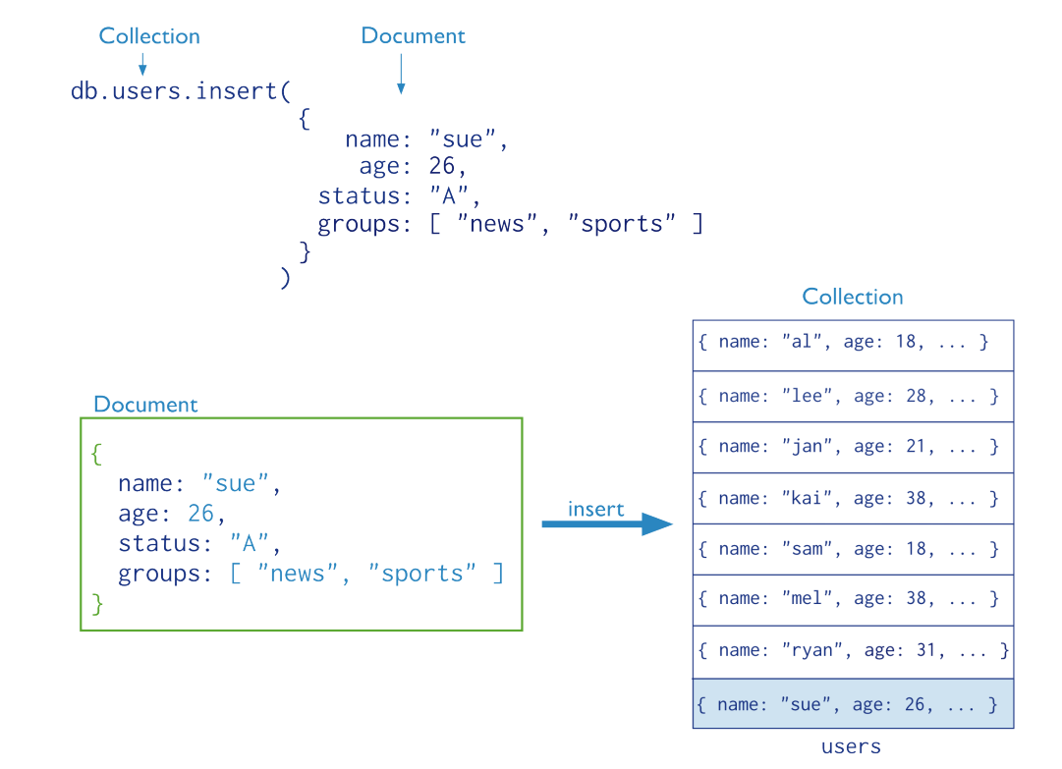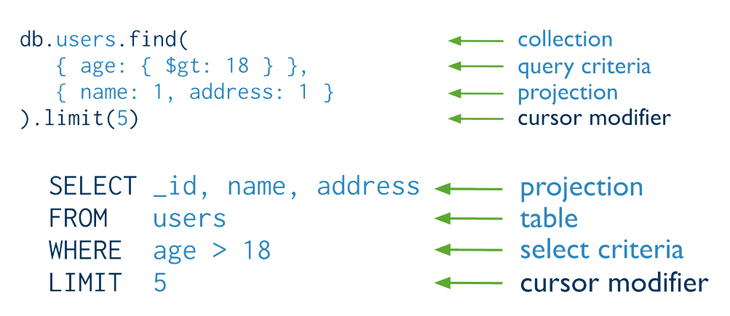

**MongoDB CRUD Operations**

CRUD operations in MongoDB refer to the four basic operations that you can perform on the database: Create, Read, Update, and Delete. These operations form the foundation for all interactions with the database.

**1. Create (Insert)**

Creating data in MongoDB involves inserting new documents into a collection. Documents are JSON-like structures composed of field and value pairs. MongoDB stores these documents in collections, which are analogous to tables in relational databases.

* **Insert a Single Document:**

db.collection.insertOne({ field1: "value1", field2: "value2" });

* **Insert Multiple Documents:**

db.collection.insertMany([

{ field1: "value1", field2: "value2" },

{ field1: "value3", field2: "value4" }

]);

**2. Read (Query)**

Reading data in MongoDB involves querying a collection to retrieve documents that match specific criteria. Queries can be refined using projections, which specify the fields to return, and modifiers like sort, limit, and skip.

* **Basic Query:**

db.collection.find({ field1: "value1" });

* **Query with Projection:**

db.collection.find({ field1: "value1" }, { field2: 1, field3: 1 });

* **Query with Sort, Limit, and Skip:**

db.collection.find({ field1: "value1" }).sort({ field2: 1 }).limit(10).skip(5);

**3. Update**

Updating data in MongoDB involves modifying existing documents in a collection. You can update specific fields of the documents that match the given criteria.

* **Update a Single Document:**

db.collection.updateOne({ field1: "value1" }, { $set: { field2: "new_value" } });

* **Update Multiple Documents:**

db.collection.updateMany({ field1: "value1" }, { $set: { field2: "new_value" } });

* **Replace a Document:**

db.collection.replaceOne({ field1: "value1" }, { field1: "value1", field2: "new_value", field3: "value3" });

**4. Delete**

Deleting data in MongoDB involves removing documents from a collection based on specific criteria.

* **Delete a Single Document:**

db.collection.deleteOne({ field1: "value1" });

* **Delete Multiple Documents:**

db.collection.deleteMany({ field1: "value1" });

**Key Concepts**

* **Documents:** JSON-like field and value pairs stored in BSON format.
* **Collections:** Groups of related documents, similar to tables in relational databases.
* **BSON:** Binary representation of JSON with additional type information.

**Example**

Consider a user’s collection with the following document:

{

_id: ObjectId("507f191e810c19729de860ea"),

name: "Alice",

age: 30,

email: "alice@example.com"

}

* **Insert:**

db.users.insertOne({ name: "Bob", age: 25, email: "bob@example.com" });

* **Query:**

db.users.find({ age: { $gte: 25 } });

* **Update:**

db.users.updateOne({ name: "Alice" }, { $set: { age: 31 } });

* **Delete:**

db.users.deleteOne({ name: "Bob" });

CRUD operations provide the essential methods for interacting with MongoDB, allowing you to manage your data effectively.

**Distributed Queries in MongoDB**

1. **Read Operations to Sharded Clusters**

* **Sharded Clusters:** These partition a dataset across multiple mongod instances, making it seem like one large database to the application.
* **Querying Sharded Collections:**
  + **With Shard Key:** If a query includes the shard key, it can be efficiently routed to the specific shard that contains the data.
  + **Without Shard Key:** If the query does not include the shard key, it must be sent to all shards, which is less efficient, especially in large clusters.
* **Replica Set Shards:** Read operations from secondary members might not be up-to-date with the primary. This can lead to non-monotonic reads (inconsistent data over time).

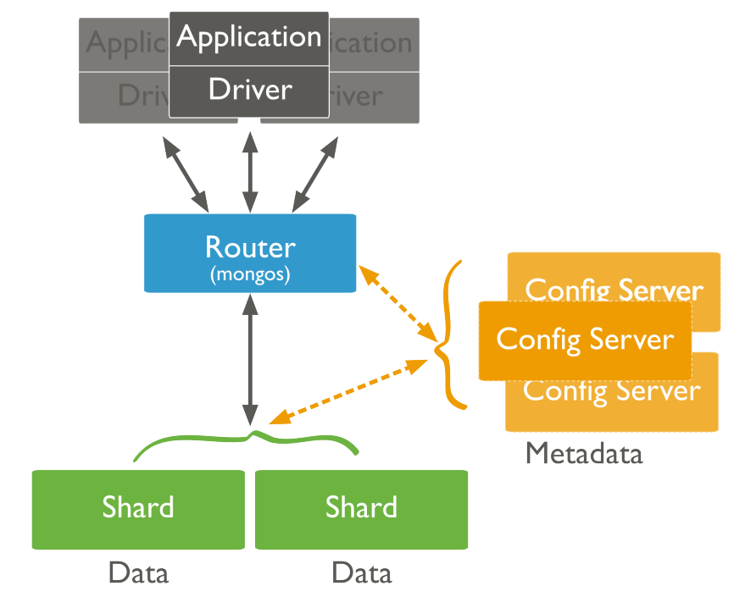

1. **Read Operations to Replica Sets**

* **Default Behavior:** By default, read operations are directed to the primary member of a replica set.
* **Read Preferences:** Clients can specify preferences to read from:
  + **Secondaries:** Useful for distributing read load and improving read performance.
  + **Nearest Member:** Helps reduce latency in geographically distributed deployments.
  + **Scenarios:** Read preferences are useful for high read volumes, backup operations, and during primary failover.
* **Non-Monotonic Reads:** Reading from secondary members might return outdated data, causing inconsistencies.

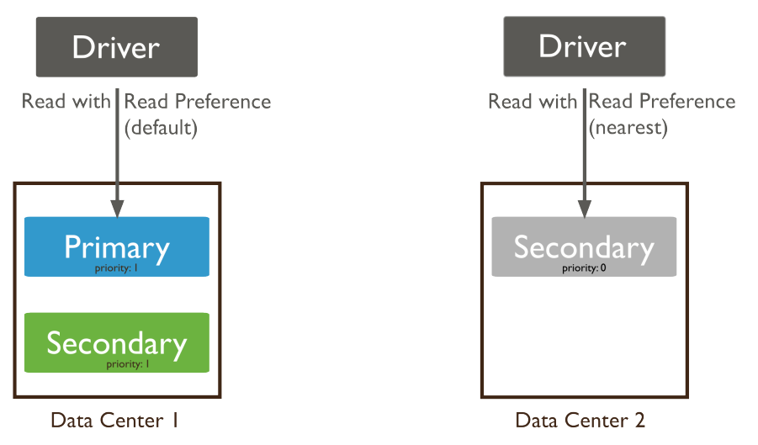

**MongoDB Write Operations**

Write operations in MongoDB are actions that create or modify data within the database. These operations target a single collection and are atomic at the document level, ensuring that each write operation either fully completes or not at all, preventing partial updates. There are three main classes of write operations: **Insert**, **Update**, and **Remove**.

**Insert Operations**

* **Function:** Adds new documents to a collection.
* **Method:** db.collection.insert()
* **Behavior:** If a document does not have an _id field, MongoDB automatically adds one with a unique ObjectId. If the _id field is specified, its value must be unique within the collection.
* **Example:**

db.users.insert({

name: "sue",

age: 26,

status: "A"

})

* **Upsert Option:** Some methods with the upsert option can insert a document if no matching document exists for a query.

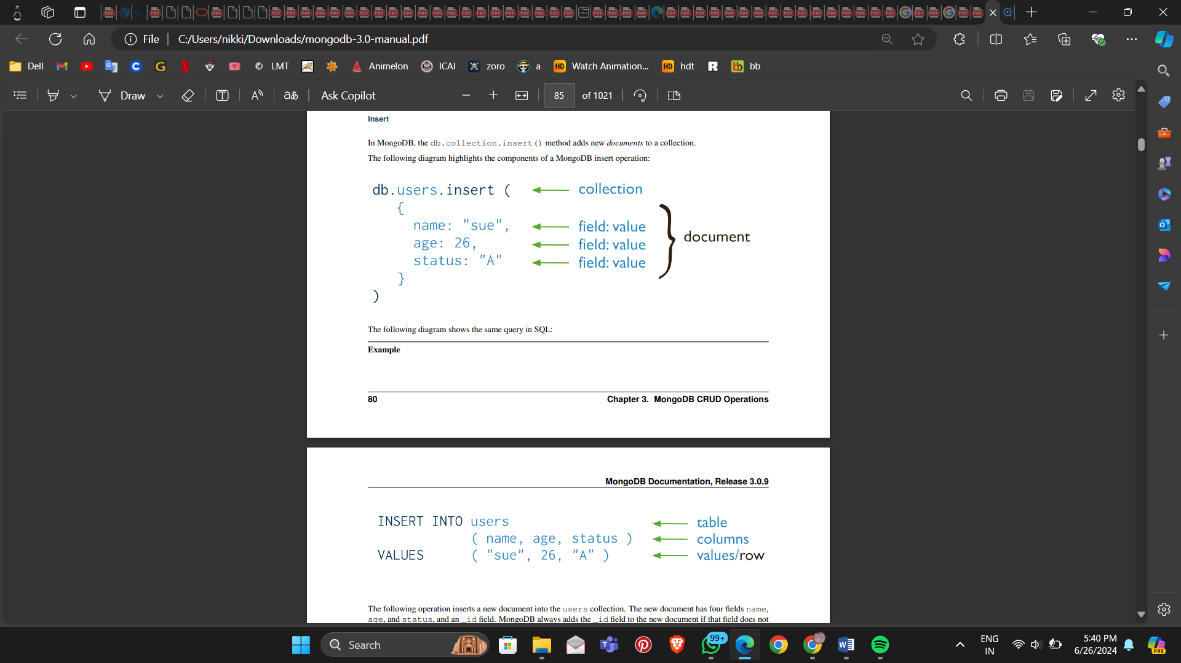



**Update Operations**

* **Function:** Modifies existing documents in a collection.
* **Method:** db.collection.update()
* **Components:**
  + **Query Criteria:** Determines which documents to update.
  + **Update Document:** Specifies the modifications.
  + **Options:** Such as multi to update multiple documents.
* **Behavior:** By default, updates a single document, but with multi: true, it can update all matching documents. Can update specific fields or replace entire documents.
* **Example:**

db.users.update(

{ age: { $gt: 18 } },

{ $set: { status: "A" } },

{ multi: true }

)

* **Upsert Option:** If upsert: true is specified and no documents match the query, a new document is created.

**Remove Operations**

* **Function:** Deletes documents from a collection.
* **Method:** db.collection.remove()
* **Components:**
  + **Query Criteria:** Determines which documents to remove.
* **Behavior:** By default, removes all documents that match the query, but can be limited to a single document.
* **Example:**

db.users.remove({ status: "D" })

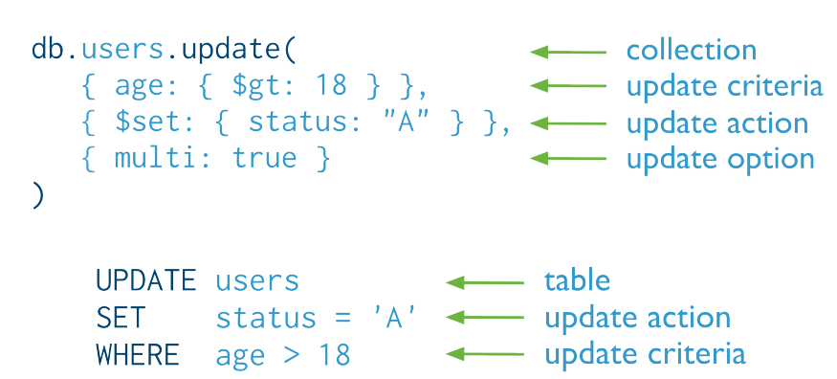

**Isolation of Write Operations**

* **Atomicity:** Modifications to a single document are atomic. However, operations affecting multiple documents are not atomic, meaning other operations can interleave.
* **Isolation Operator:** Can be used to attempt to isolate a write operation that affects multiple documents.

**Indexes in MongoDB**

Indexes in MongoDB play a crucial role in enhancing the performance of read operations by allowing the database to quickly locate and access the desired data. However, they also introduce some overhead during write operations, including inserts, updates, and deletes.

**Impact on Write Operations**

* **Overhead:** Each write operation in MongoDB requires updating every index associated with the collection in addition to modifying the data itself. This process adds overhead, potentially affecting write performance.
* **Sparse vs. Non-Sparse Indexes:** The overhead for updating sparse indexes (indexes that exclude documents where the indexed field is missing) is generally less than that for non-sparse indexes. Additionally, for non-sparse indexes, updates that do not change the record size have reduced indexing overhead.

**Performance Considerations**

* **Insertion Penalty:** While indexes introduce a performance penalty during write operations, the performance gains they provide for read operations often outweigh this penalty.
* **Optimization:** To optimize write performance, carefully evaluate the need for new indexes and ensure existing indexes are effectively used by your queries.

**Document Growth and MMAPv1 Storage Engine**

* **Document Size Increase:** Certain update operations that increase document size (e.g., adding a new field) may necessitate relocating the document on disk if it exceeds its allocated space.
* **Relocation Impact:** Document relocations, especially in indexed collections, can significantly impact write throughput since MongoDB must update all index entries.
* **Power of 2 Sized Allocations:** Introduced in version 3.0.0, this feature helps minimize reallocations by allocating document space in sizes that are powers of 2, enhancing the efficient reuse of free space and reducing the frequency of reallocations.

**Storage Performance**

* **Hardware Factors:** The performance of write operations is influenced by the storage system's capabilities, including factors like random access patterns, disk caches, and RAID configurations. Solid-state drives (SSDs) can significantly outperform spinning hard disks (HDDs) for random workloads.
* **Journaling:** MongoDB uses write-ahead logging to an on-disk journal for durability. While journaling ensures data durability in case of a crash, it also introduces additional write operations that can impact performance. To mitigate this, consider:
  + **Separate Devices:** Placing the journal on a separate device from the data files to avoid contention for I/O resources.
  + **Write Concern:** Adjusting the write concern to balance between durability and performance.
  + **Journal Commit Interval:** Configuring the commitIntervalMs run-time option to control the frequency of journal writes, balancing between write performance and the likelihood of unrecorded operations in case of failure.

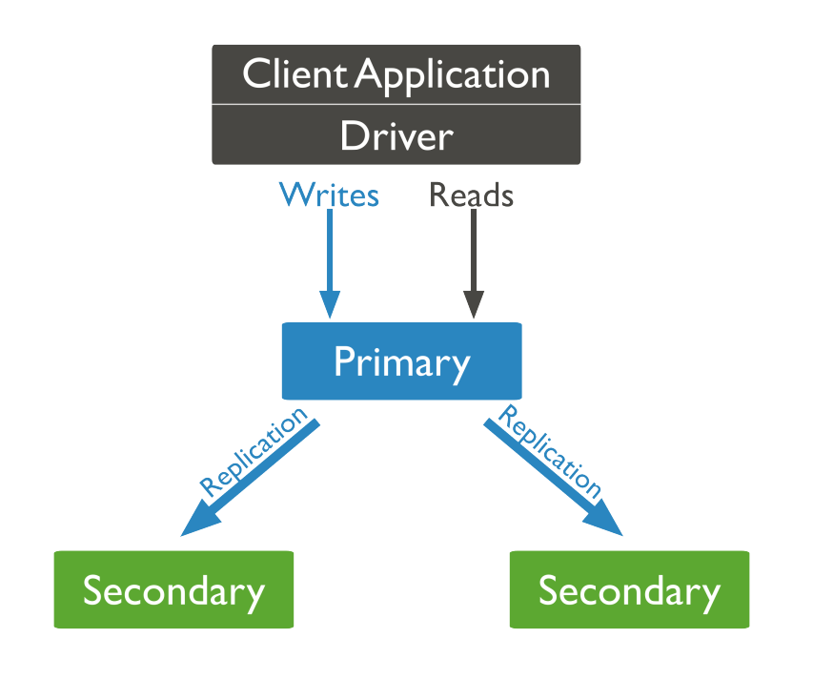

**Working with Arrays in MongoDB**

MongoDB allows for flexible querying and manipulation of arrays within documents. Here’s how you can query arrays and their elements effectively:

1. **Exact Match on an Array**

To find documents where an array field matches exactly a specified array, including order:

db.inventory.find({ ratings: [ 5, 8, 9 ] })

This query returns documents where the ratings array matches [ 5, 8, 9 ].

1. **Match an Array Element**

To find documents where an array contains a specific element:

db.inventory.find({ ratings: 5 })

This query returns documents where the ratings array contains the element 5.

1. **Match a Specific Element of an Array**

To match documents based on a specific element's value at a certain index in the array:

db.inventory.find({ 'ratings.0': 5 })

This query returns documents where the first element (index 0) of the ratings array is 5.

1. **Specify Multiple Criteria for Array Elements**

Using $elemMatch, you can specify multiple conditions that at least one array element must satisfy:

db.inventory.find({ ratings: { $elemMatch: { $gt: 5, $lt: 9 } } })

This query returns documents where the ratings array contains at least one element that is greater than ($gt) 5 and less than ($lt) 9.

1. **Combination of Elements Satisfies the Criteria**

Without $elemMatch, MongoDB matches documents where different elements in the array satisfy different parts of the query:

db.inventory.find({ ratings: { $gt: 5, $lt: 9 } })

This query returns documents where some combination of elements in the ratings array satisfy the conditions.

1. **Array of Embedded Documents**

When arrays contain embedded documents, you can query based on fields within these embedded documents using dot notation:

* **Match a Field in the Embedded Document Using Array Index:**

db.inventory.find({ 'memos.0.by': 'shipping' })

Returns documents where the first element (index 0) in the memos array has a by field equal to 'shipping'.

* **Match a Field Without Specifying Array Index:**

db.inventory.find({ 'memos.by': 'shipping' })

Returns documents where any element in the memos array has a by field equal to 'shipping'.

### Creating and Managing Capped Collections in MongoDB

Capped collections are fixed-size collections that support high-throughput operations and can automatically discard the oldest documents when they reach their size limit.

#### Creating a Capped Collection

To create a capped collection, use the createCollection method. You must specify the maximum size of the collection in bytes. Optionally, you can also specify the maximum number of documents the collection can hold.

// Create a capped collection with a size limit of 100,000 bytes

db.createCollection("log", { capped: true, size: 100000 })

// Create a capped collection with a size limit of 5,242,880 bytes and a maximum of 5,000 documents

db.createCollection("log", { capped: true, size: 5242880, max: 5000 })

**Important:** The size argument is always required. If the size is less than or equal to 4096 bytes, MongoDB will cap it at 4096 bytes. If the provided size is not a multiple of 256, MongoDB will round it up to the nearest multiple of 256.

#### Querying a Capped Collection

When querying a capped collection, the order of results will be the same as the insertion order if no sort order is specified.

To retrieve documents in reverse insertion order:

db.cappedCollection.find().sort({ $natural: -1 })

#### Checking if a Collection is Capped

To determine if a collection is capped, use the isCapped method:

db.collection.isCapped()

#### Converting a Non-Capped Collection to a Capped Collection

You can convert an existing non-capped collection to a capped collection using the convertToCapped command:

db.runCommand({ "convertToCapped": "mycoll", size: 100000 })

**Warning:** This command obtains a global write lock and will block other operations until it completes.

### Using MongoDB's mongoimport and mongoexport Tools

MongoDB’s mongoimport and mongoexport tools facilitate working with data in human-readable Extended JSON or CSV formats. These tools are ideal for simple data ingestion and export tasks, backup, or migration of small data subsets. For more complex data migration tasks, you may need to write custom import/export scripts using a MongoDB client driver.

**Important:** Avoid using mongoimport and mongoexport for full instance production backups, as they do not preserve all rich BSON data types. Use mongodump and mongorestore for such purposes.

#### Exporting Collections with mongoexport

1. **Export in CSV Format**
   * **Example:** Export the contacts collection from the users database to a CSV file.

mongoexport --db users --collection contacts --type=csv --fields name,address --out /opt/backups/contacts.csv

* + **Using a Fields File:**

Create a fields.txt file with each field on a separate line:

name

address

Export using the fields file:

mongoexport --db users --collection contacts --type=csv --fieldFile fields.txt --out /opt/backups/contacts.csv

1. **Export in JSON Format**
   * **Example:** Export the contacts collection from the sales database to a JSON file.

mongoexport --db sales --collection contacts --out contacts.json

1. **Export from a Remote Host with Authentication**
   * **Example:** Export the contacts collection from the marketing database on a remote MongoDB instance with authentication.

mongoexport --host mongodb1.example.net --port 37017 --username user --password pass --collection contacts --db marketing --out mdb1-examplenet.json

1. **Export Query Results**
   * **Example:** Export documents from the contacts collection in the sales database where the field has a value of 1.

mongoexport --db sales --collection contacts --query '{"field": 1}'

#### Importing Collections with mongoimport

1. **Simple JSON Import**
   * **Example:** Import JSON data from contacts.json into the contacts collection in the users database.

mongoimport --db users --collection contacts --file contacts.json

1. **Import JSON to Remote Host with Authentication**
   * **Example:** Import JSON data from /opt/backups/mdb1-examplenet.json into the contacts collection in the marketing database on a remote MongoDB instance with authentication.

mongoimport --host mongodb1.example.net --port 37017 --username user --password pass --collection contacts --db marketing --file /opt/backups/mdb1-examplenet.json

1. **CSV Import**
   * **Example:** Import CSV data from /opt/backups/contacts.csv into the contacts collection in the users database.

mongoimport --db users --collection contacts --type csv --headerline --file /opt/backups/contacts.csv

* + If you do not specify the --collection option, mongoimport uses the input file name (without the extension) as the collection name. The following command is equivalent to the above:

mongoimport --db users --type csv --headerline --file /opt/backups/contacts.csv

* + Use the --ignoreBlanks option to avoid inserting fields with null values for blank fields in CSV or TSV files:

mongoimport --db users --collection contacts --type csv --headerline --ignoreBlanks --file

**Conclusion**

MongoDB's robust document-oriented architecture, combined with its powerful features such as flexible schema design, high availability, and horizontal scaling, makes it an ideal choice for modern applications that require efficient data management and scalability. From basic CRUD operations to advanced functionalities like distributed queries, indexing, and capped collections, MongoDB offers a comprehensive set of tools for developers to build and manage applications with dynamic and complex data requirements. By understanding and utilizing MongoDB's key concepts, installation processes, and operational techniques, users can fully leverage its capabilities to enhance their data storage and retrieval systems, ensuring high performance and flexibility in their database solutions.